Unit Testing (UT) 101

**HOP02 – JUnit in VSCode: Install JUnit and Run Unit Tests**

4/12/2019 Developed by Clark Jason Ngo

4/12/2019 Tested by Peng Wang

4/15/2019 Tested by Sam Chung & Jin Chang

10/10/2020 Revised by Kim Nguyen

Center for Information Assurance (CIAE) @City University of Seattle (CityU)

    

**Caution**

* If you already finished this module through any CityU Technology Institute (TI) courses,  
  just skim this module and skip it.
* Some version numbers may not match with the newly released ones.  
  If so, stay with the most recent ones.
* We target Windows OS. So, Mac may have different options.
* We cannot explain every steps. This cookbook always needs your own creative judgement.

**Learning Outcomes**

* What is Junit?
* Creating a Maven Java Project
* Upgrade JUnit 4 to JUnit 5
* Modify, build, and compile our project – App.java and AppTest.java
* View Tests and Test Report
* Check the test coverage report

**What is JUnit?**

“*JUnit 5* is the next generation of JUnit. The goal is to create an up-to-date foundation for developer-side testing on the JVM. This includes focusing on Java 8 and above, as well as enabling many different styles of testing.”

Source: <https://junit.org/junit5/>

**Creating a Maven Java Project**

1. **Generate your project “my-app”**

In VSCode, open the repository you cloned for this week’s assignment. Make sure you are in the right path, for example:

CS570/HOP-hands-on-practice-YourGitHubUserName/Module2

For this week, your work should be saved under Module 2 folder.

Open your VSCode terminal / command:

* 1. Type the following command.

**mvn archetype:generate -DgroupId=com.mycompany.app -DartifactId=my-app -DarchetypeArtifactId=maven-archetype-quickstart -DarchetypeVersion=1.4 -DinteractiveMode=false**

**[NOTE: the directory path in the screen shot might be different from yours]**

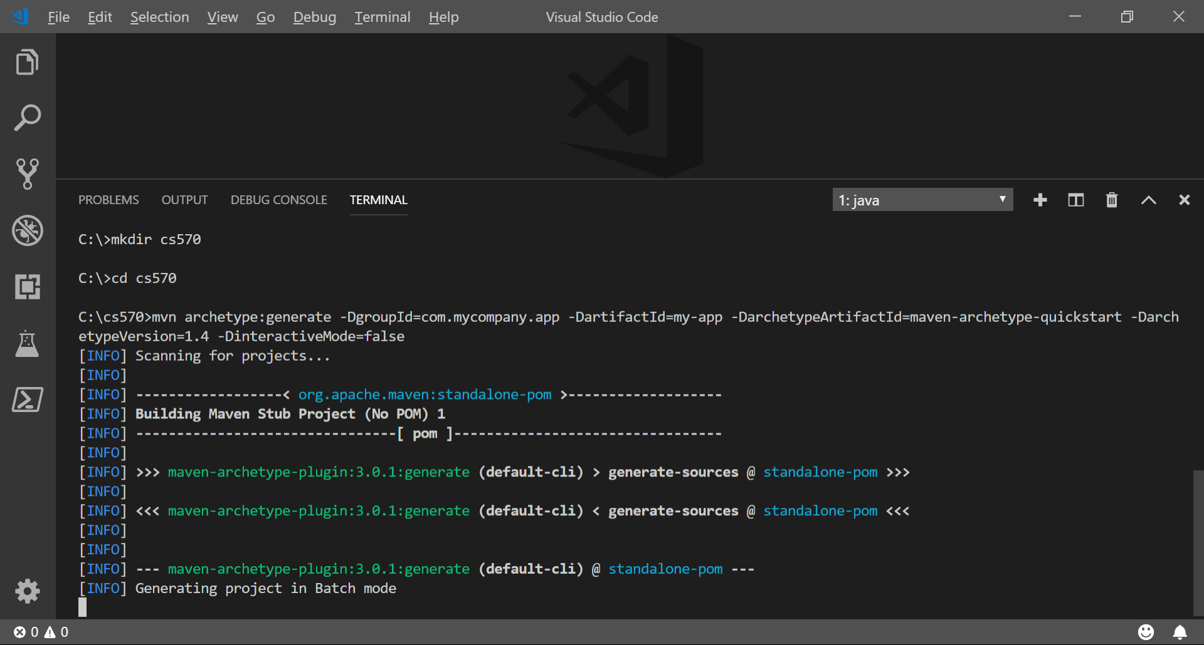

* 1. Type dir to see the “my-app” project folder.

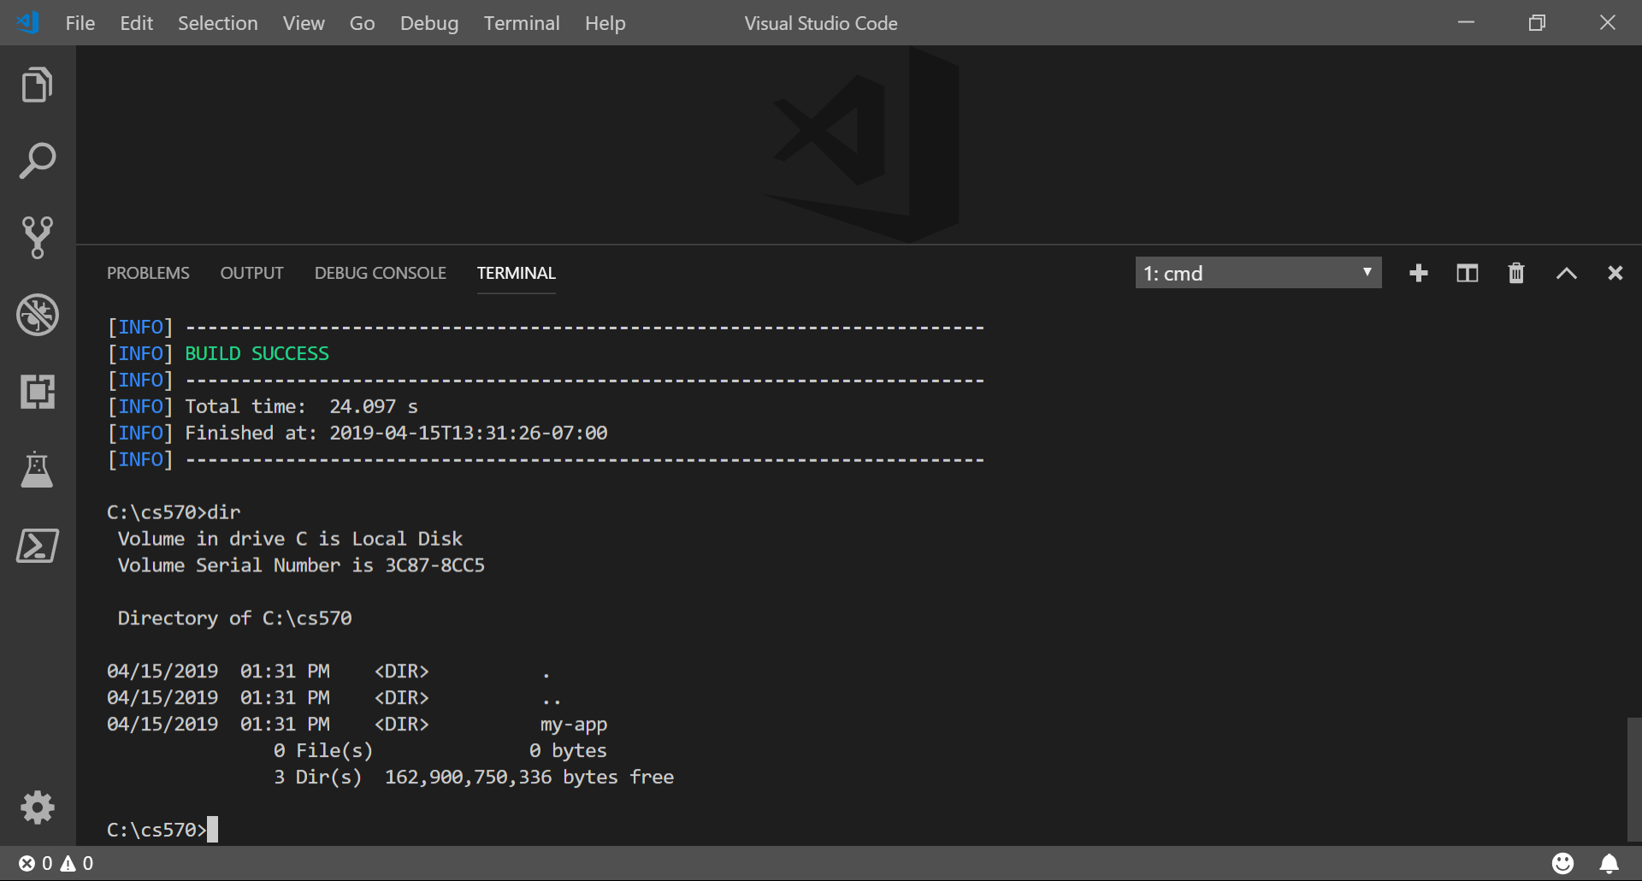

You can see a folder named my-app generated for you. You can see two directories under the “src” directory.

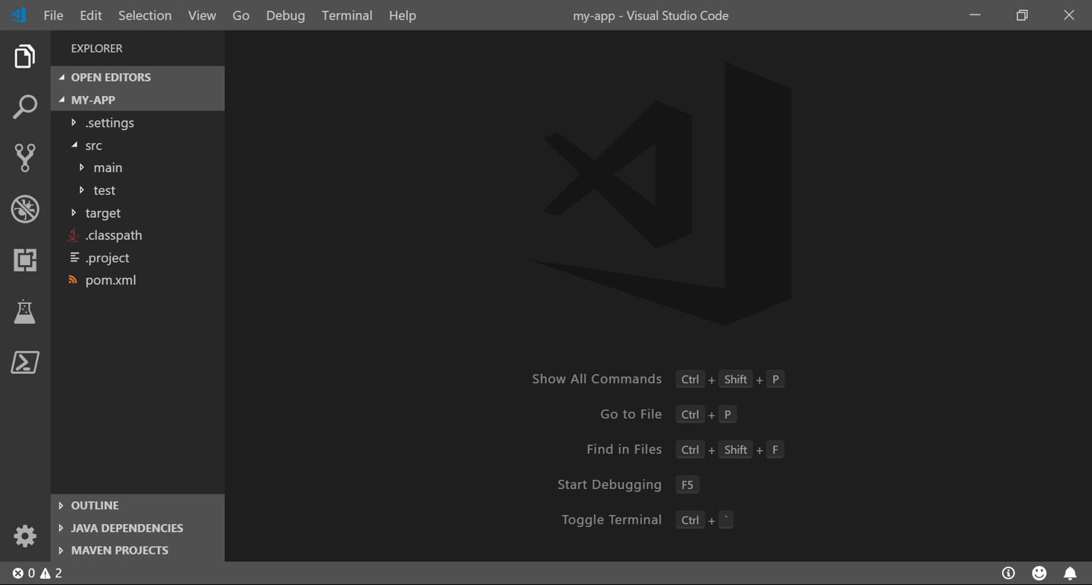

1. **Build the project**
   1. In your terminal / command prompt, type the following command.   
      This command takes the already compiled code and package them in a distributable format like *.jar.

**mvn package**

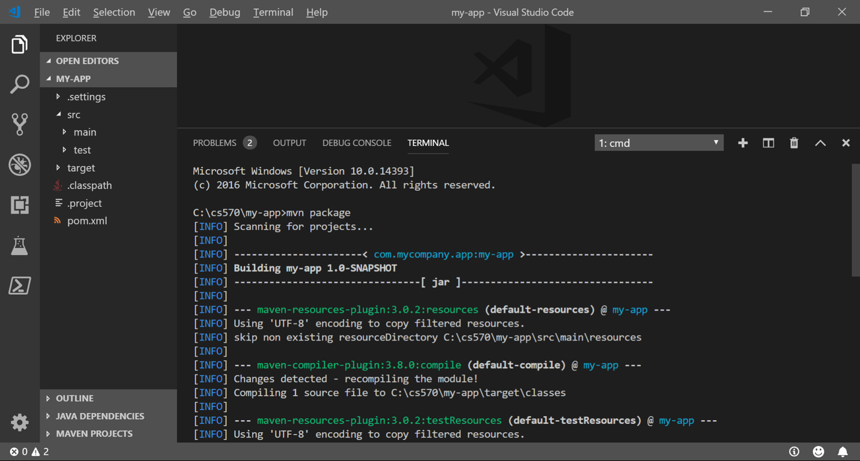

* 1. Type “dir” to see what were created.

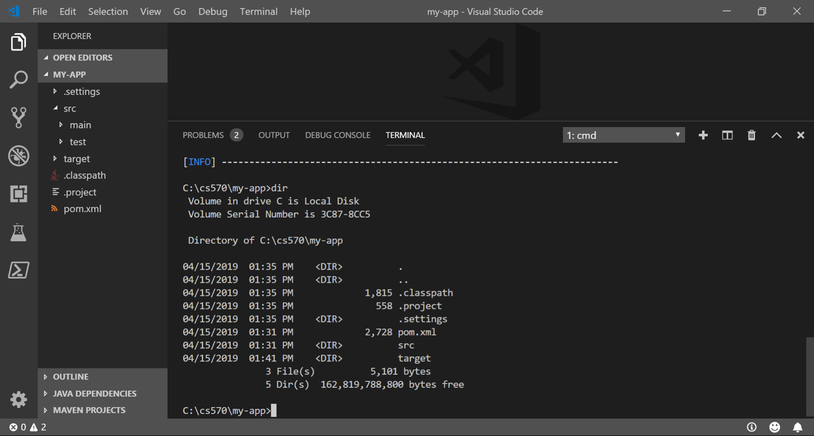

1. **Compile the project**
   1. In your terminal / command prompt, type the following command. Please note that –cp (aka. classpath) is a flag to use the jar file created from the previous step during this compilation.  
      **java -cp target/my-app-1.0-SNAPSHOT.jar com.mycompany.app.App**
   2. **You should get an output with**Hello World!

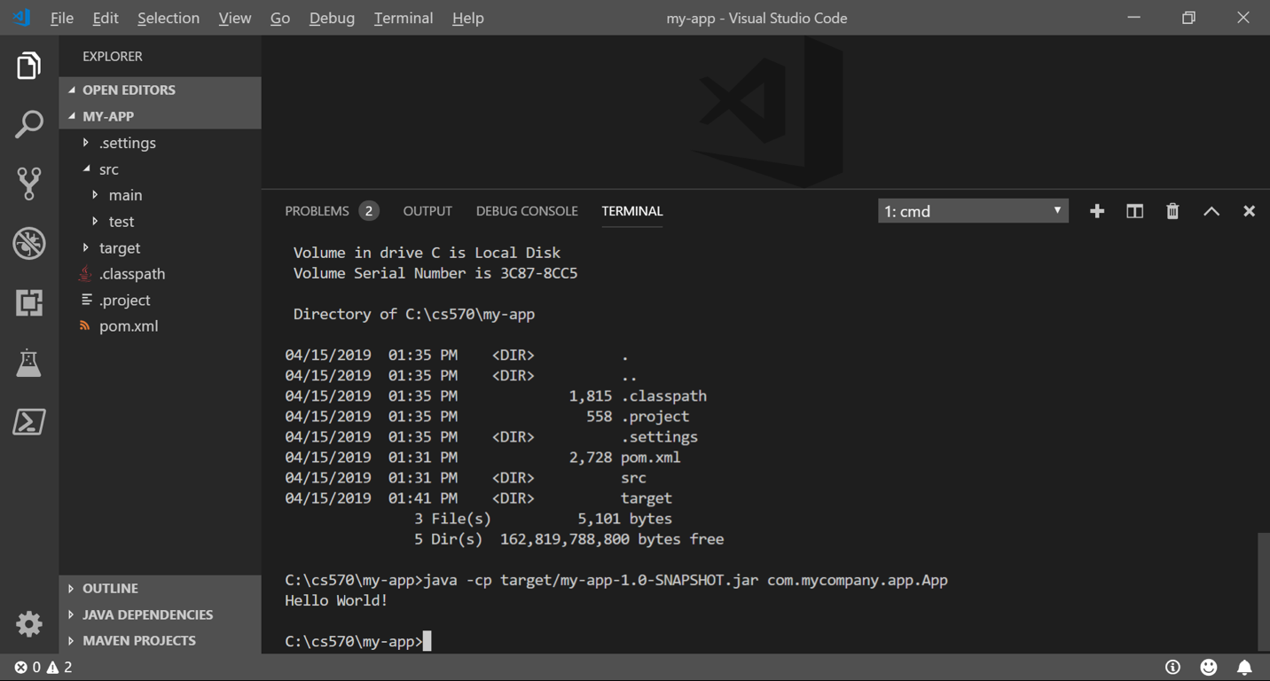

* 1. Open “App.java” under “my-app/src/main/java/com/mycompany/app”

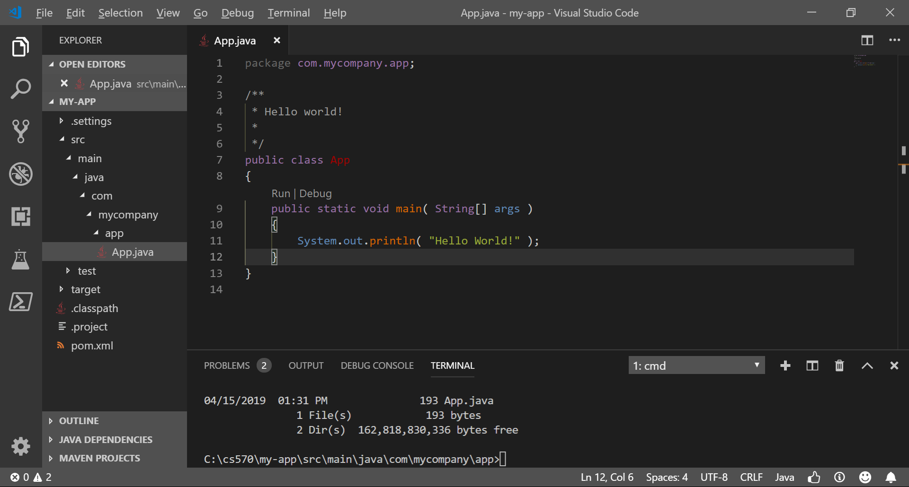

* 1. Open “App.class” under “target/classes/com/mycompany/app”

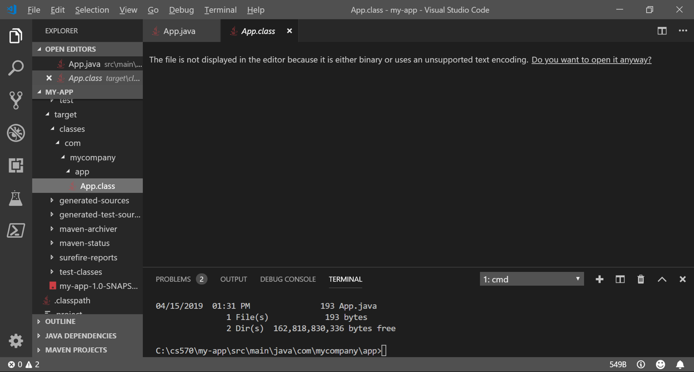

* 1. Open “AppTest.java” under “my-app/src/test/java/com/mycompany/app”

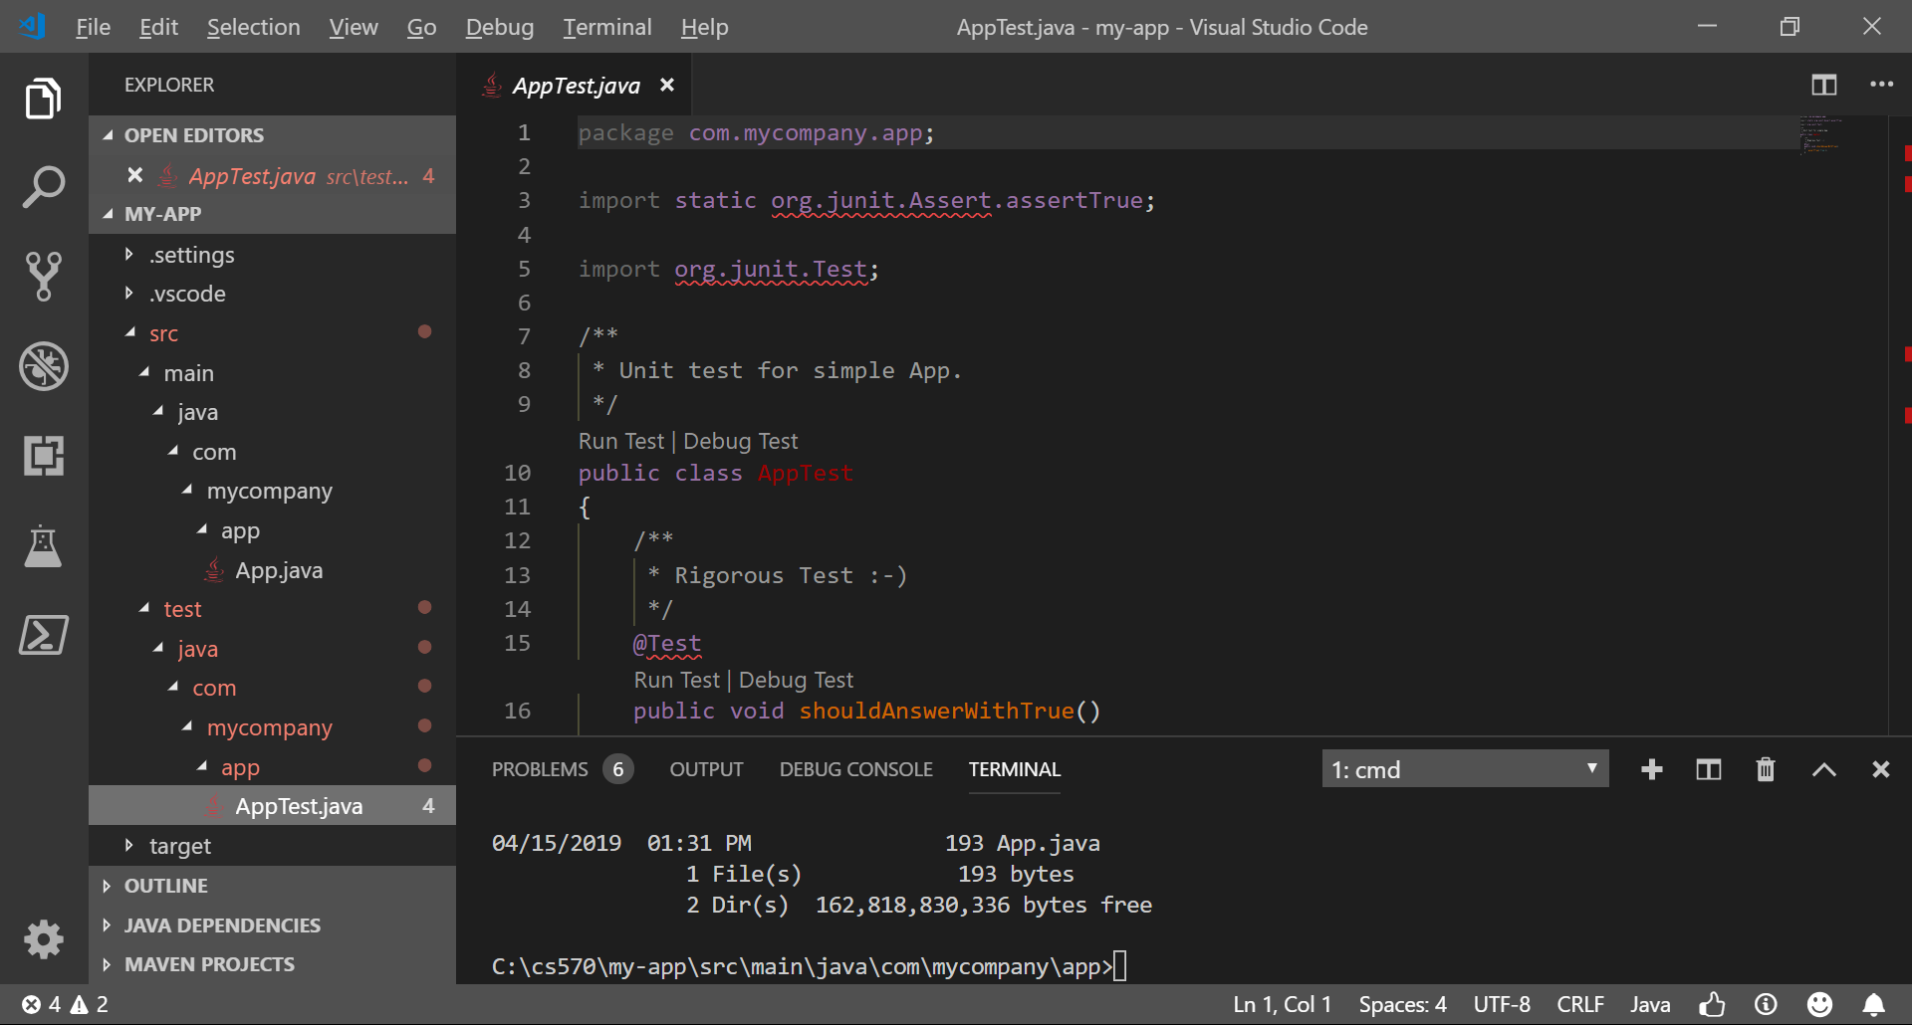

**Upgrade JUnit 4 to JUnit 5**

1. **Open the Project Object Model (POM) file of the “my-app” project, “pom.xml”**<https://maven.apache.org/guides/introduction/introduction-to-the-pom.html#What_is_a_POM>

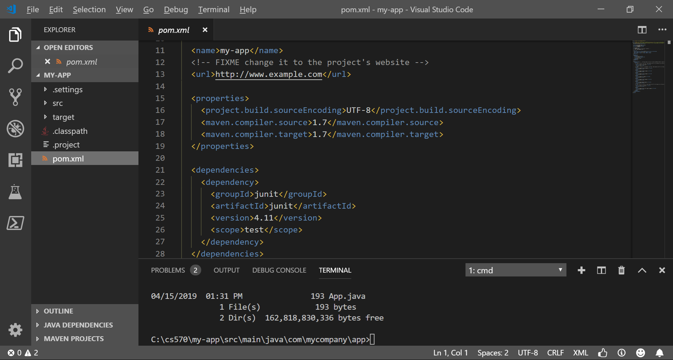

1. **Replace** the dependencies

<dependencies>

<dependency>

<groupId>junit</groupId>

<artifactId>junit</artifactId>

<version>4.11</version>

<scope>test</scope>

</dependency>

</dependencies>

with this:

<dependencies>

<dependency>

<groupId>org.junit.jupiter</groupId>

<artifactId>junit-jupiter-api</artifactId>

<version>5.4.2</version>

<scope>test</scope>

</dependency>

<dependency>

<groupId>org.junit.jupiter</groupId>

<artifactId>junit-jupiter-engine</artifactId>

<version>5.4.2</version>

<scope>test</scope>

</dependency>

</dependencies>

1. Please keep the same indentation.   
   Hit save.

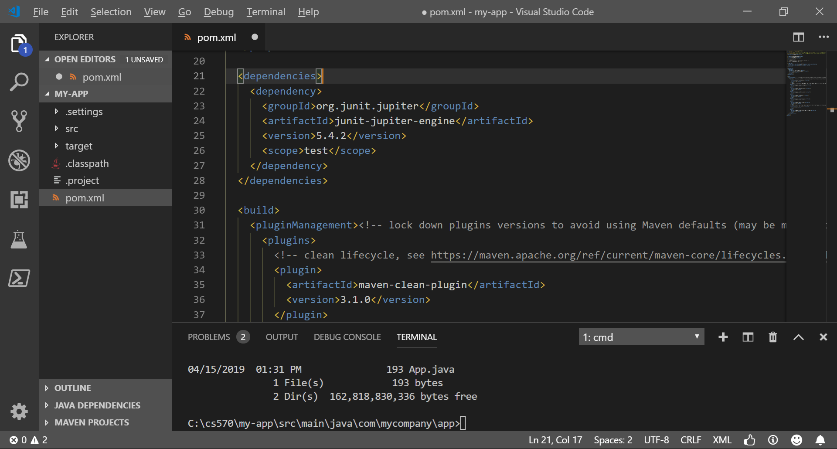

You may get the following notification. Click “Now” to synchronize.

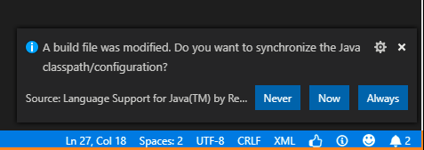

**Modify, build, and compile our project – App.java and AppTest.java**

1. Modifying App.java  
   Let’s start creating simple math functions.  
     
   Search App.java (Push control or (command) + P to type App.java)  
     
   or  
     
   Find App.java directly under *my-app/src/main/java/com/mycompany/app* folder.

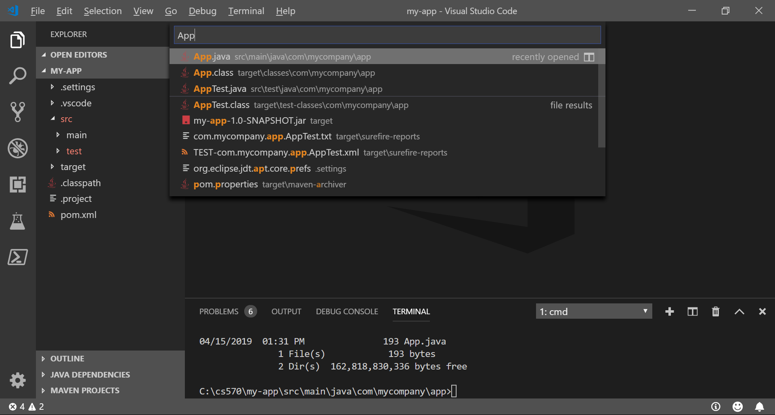

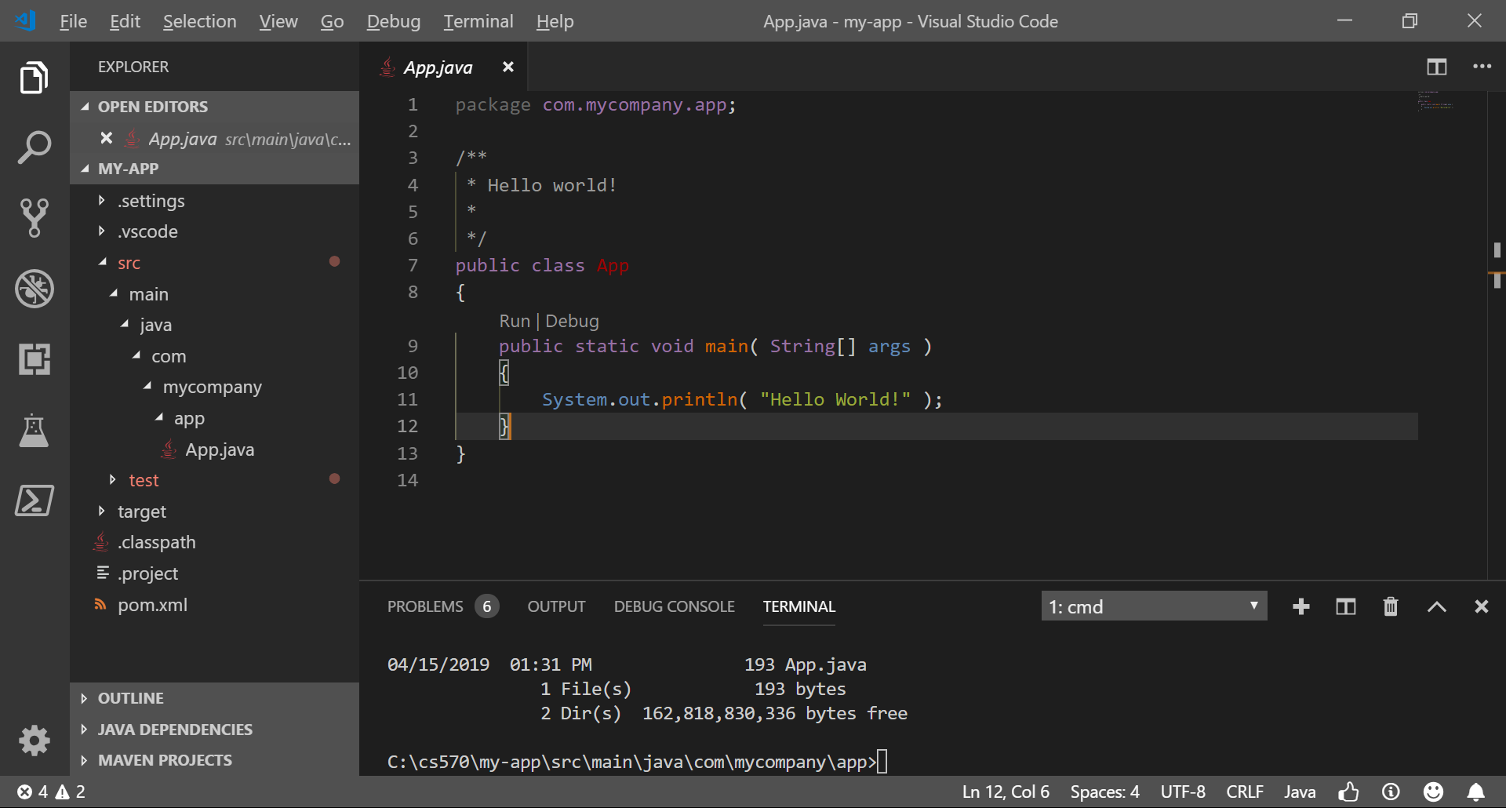

1. And then replace the contents with this code:  
   <http://bit.ly/2Z7qDqx>

package com.mycompany.app;

public class App

{

public static int add(int firstNumber, int secondNumber) {

return firstNumber + secondNumber;

}

public static int multiply(int multiplicand, int multiplier) {

return multiplicand * multiplier;

}

public static int divide(int dividend, int divisor) {

if (divisor == 0)

throw new IllegalArgumentException("Cannot divide by zero (0).");

return dividend / divisor;

}

public static void main( String[] args )

{

System.out.println(App.add(3, 3));

}

}

1. Modifying AppTest.java  
   Let’s start creating simple math functions.  
     
   Search for AppTest.java (Push control or (command) + P to type AppTest.java)  
     
   Or  
     
   Find AppTest.java directly under *my-app/src/test/java/com/mycompany/app* folder  
     
   and replace the contents with this code:

http://bit.ly/2P8itts

package com.mycompany.app;

import static org.junit.jupiter.api.Assertions.assertTrue;

import static org.junit.jupiter.api.Assertions.assertEquals;

import org.junit.jupiter.api.Test;

/**

* Unit test for simple App.

*/

public class AppTest

{

/**

* Rigorous Test :-)

*/

@Test

public void shouldAnswerWithTrue()

{

assertTrue( true );

}

@Test

public void add_TwoPlusTwo_ReturnsFour() {

// Arrange

final int expected = 4;

// Act

final int actual = App.add(2, 2);

// Assert

assertEquals(expected, actual);

}

@Test

public void multiply_FourTimesTwo_ReturnsEight() {

// Arrange

final int expected = 8;

// Act

final int actual = App.multiply(4, 2);

// Assert

assertEquals(expected, actual);

}

@Test

public void divide_TenDividedTwo_ReturnsFive() {

// Arrange

final int expected = 5;

// Act

final int actual = App.divide(10, 2);

// Assert

assertEquals(expected, actual);

}

}

1. Build the project and run the tests under the “**my-app**” directory.  
   In your terminal / command prompt:  
     
   **mvn package**  
     
   Output:

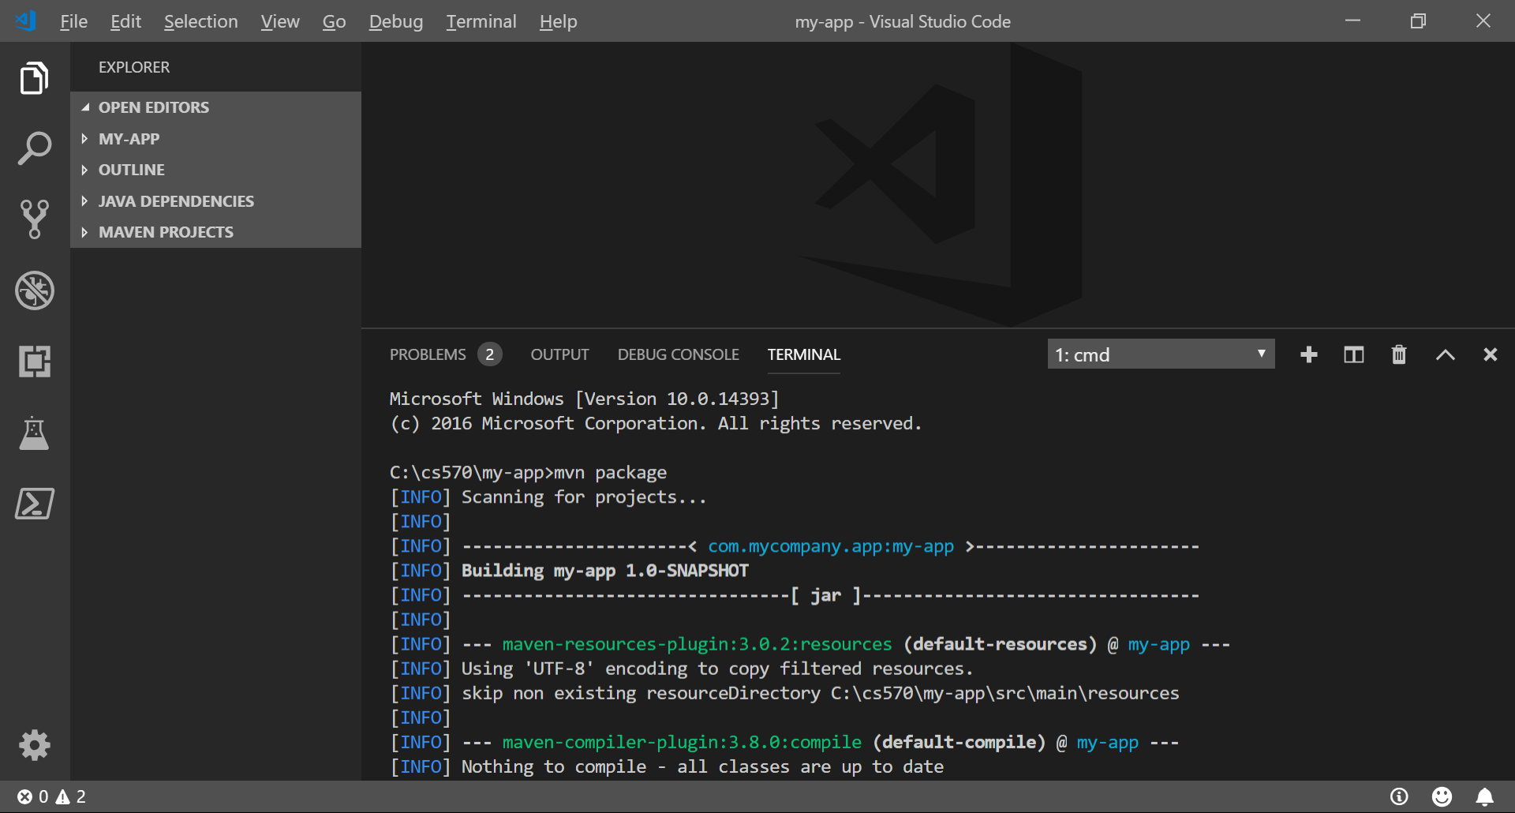

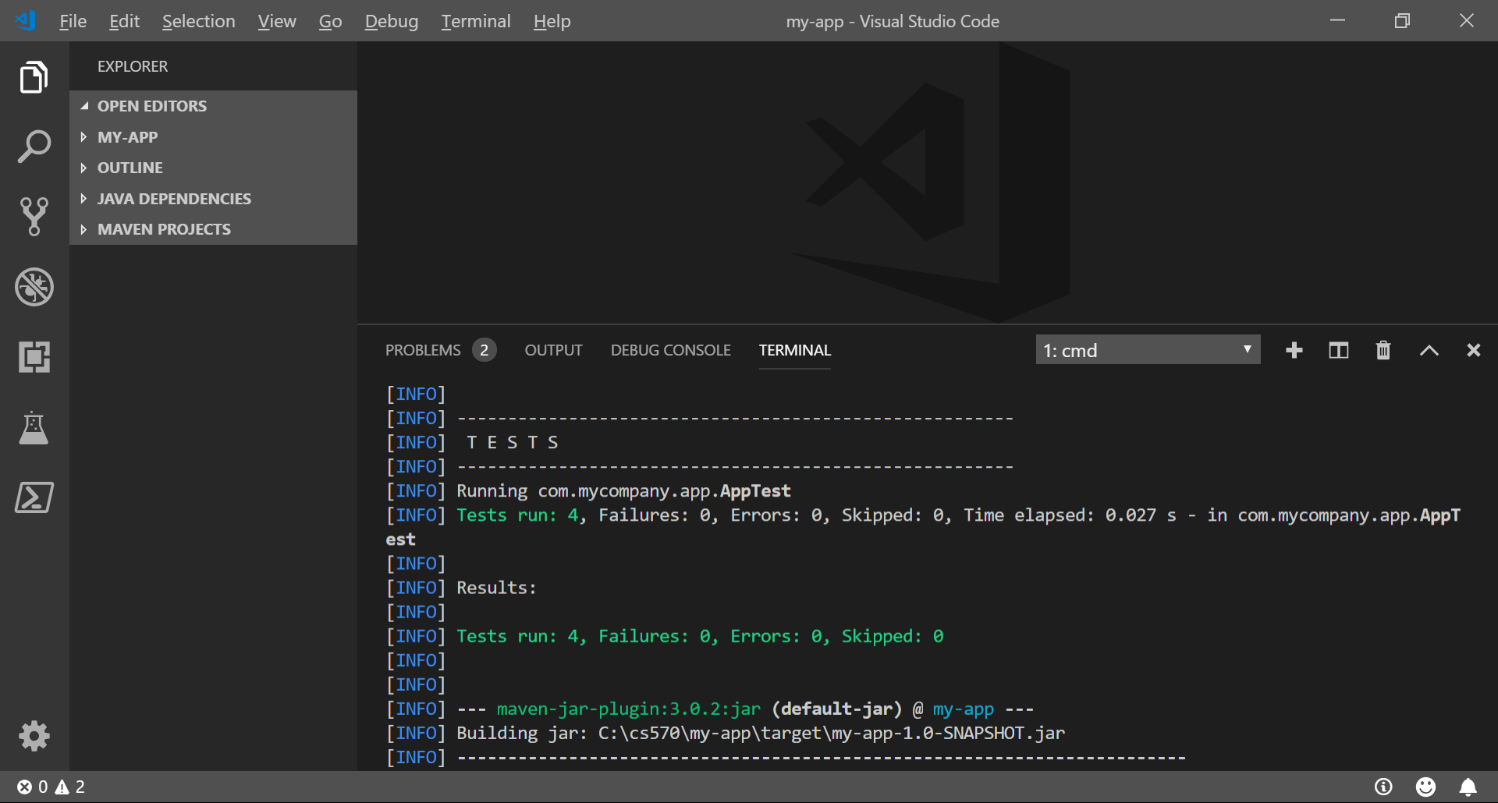

1. **Execute the project.**

In your terminal / command prompt:

java -cp target/my-app-1.0-SNAPSHOT.jar com.mycompany.app.App

**You should get an output with:**

6

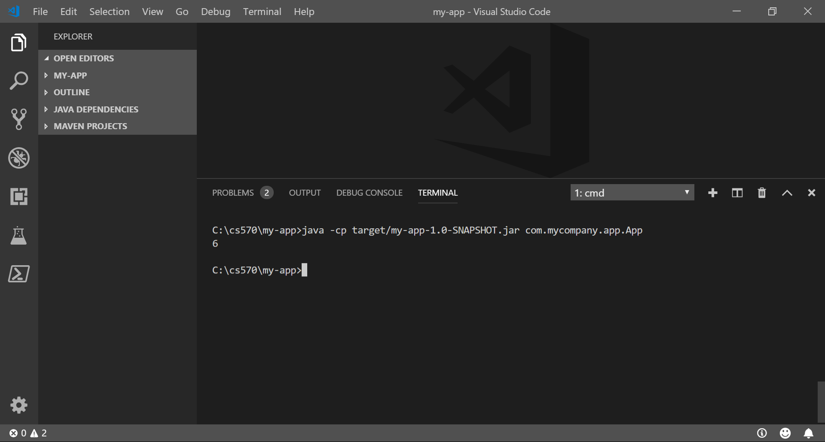

**The alternative way to Run Test in VSCode**

Click Run Test inside AppTest.java

In the example below, Run Test is located just below code line 11.



**View Tests and Test Report**



**Check the test coverage report**

1. In the VSCode open the Extension MarketPlace and search “Coverage Gutters”  
   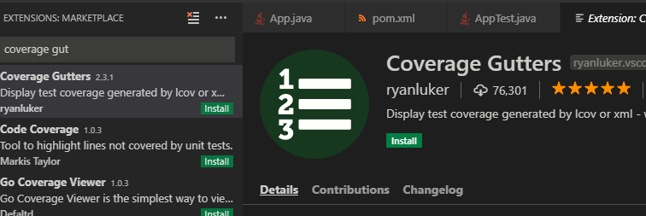
   1. for more information, <https://marketplace.visualstudio.com/items?itemName=ryanluker.vscode-coverage-gutters>
   2. Cover Gutter uses LCOV - the LTP GCOV extension, where LTP means Linux Test Project and GCOV means GNU Compiler Collection. (<https://en.wikipedia.org/wiki/Gcov>)
2. Click install button
3. Open the **pom.xml** file under your root folder and replace the content with <http://bit.ly/2Df1Oj2> to add one plugin support.

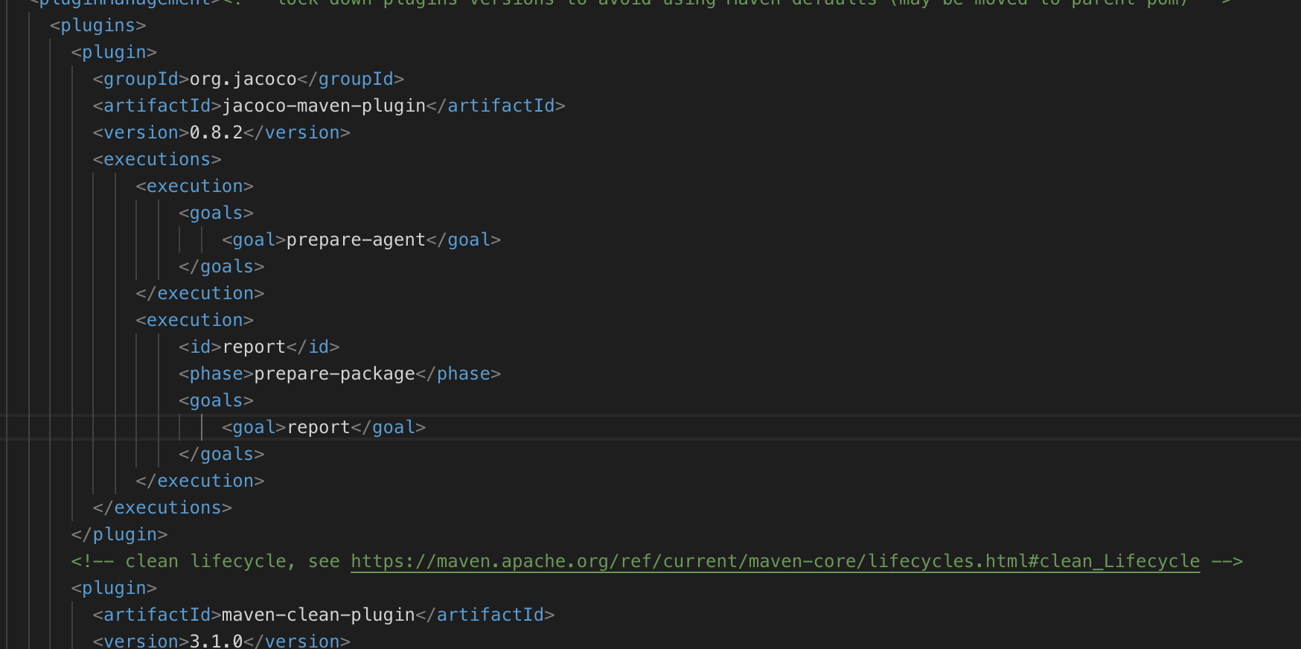

1. Open the terminal in the VSCode and run **mvn install**  
   **mvn clean jacoco:prepare-agent install jacoco:report**
2. Open your “**App.java**” file under **main/java/com/mycompany/app** folder and   
   click the Watch button to check the report

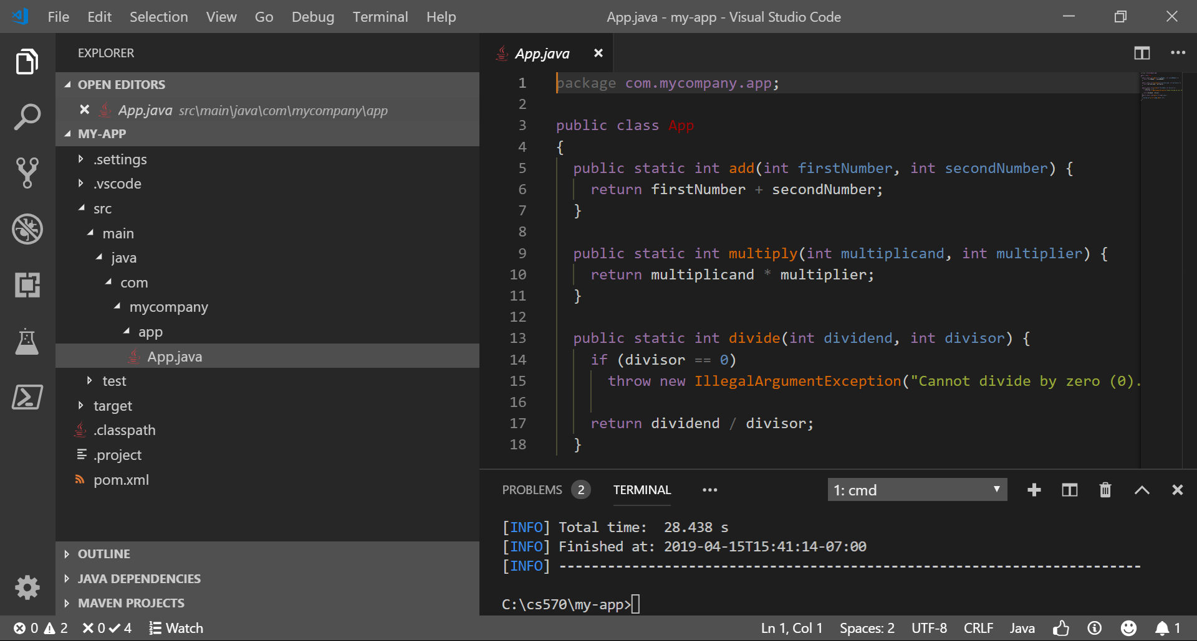

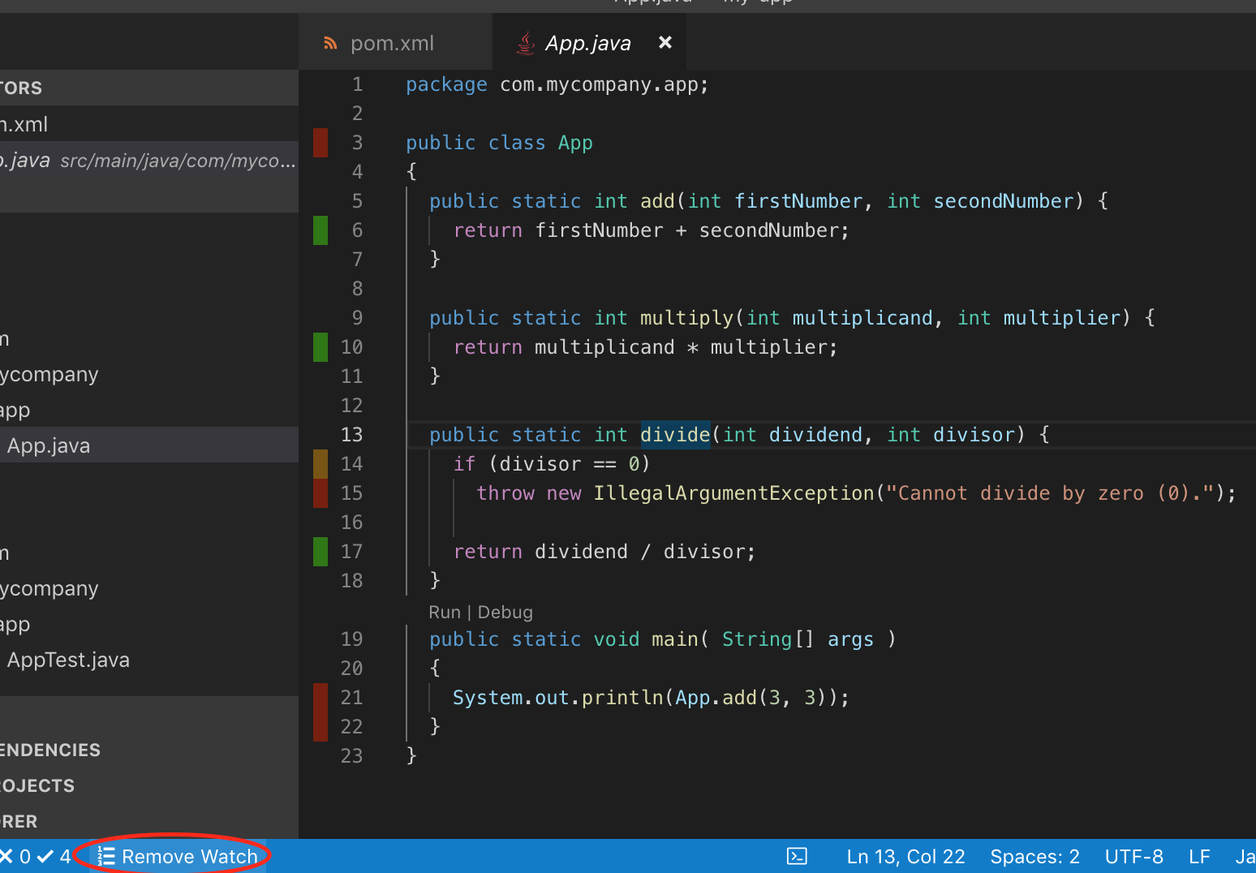

* Red bar: test code is not covered
* Yellow bar: condition is not covered
* Green bar: code is covered

1. Find the “**index.html**” file in my-app/target/site/jacoco, and ‘right-click’ on the file. Select “Copy Path”. This “index.html” contains the graphical representation of code-coverage that you just executed.



1. Then paste (Ctrl and V for Windows, Command and V for MacOS) the path in your browser.  
   You can see a very detailed test coverage report:

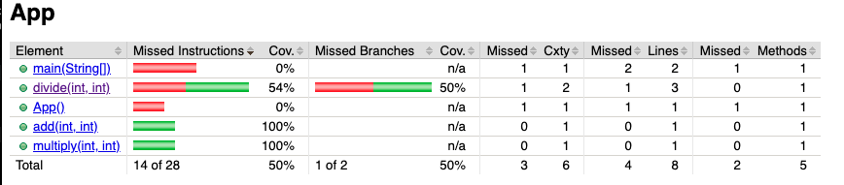

**Questions:**

Answer each question.   
Show a good reference(s) to support your answer. 

1. Why does the maven project allow two directories – src and target?

src folder contains our source code .java files. target folder contains our bytecode .class files and the .jar file.

1. Why does the maven project allow two directories under src – main and test?

Because we have our actual .java files under source packages and we have our test classes under the test section.

1. If you want to test “App.java” class, what is the name of its corresponding JUnit test class?

AppTest

1. What type of testing does JUnit provide?

Unit testing

1. What is the limitation for using JUnit?  
     
   It's not suitable for higher level testing i.e. for large test suites. Group testing cannot be done in JUnit, which is available in TestNG. Can't create HTML reports of test cases. You need to use ANT to create tests HTML reports.
2. What is Maven?

It allows us to define a list of thing to be downloaded automatically so the software can be deployed easily.

1. Why did we use VSCode instead of other IDE’s for Java such as Eclipse?

Well, I used NetBeans because I have been using it for years and it does all I ask from it :D

1. Are there other alternative testing tools for Maven projects?

Selenium, cucumber, spock, jtest.

1. Why do we use “Coverage Gutters”  
     
   It shows which lines have been executed by the tests.
2. Challenge: Create 1 or more unit test and capture a screenshot.

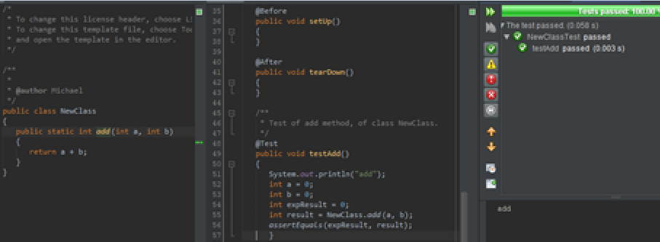

**Push your work to GitHub**

Once you completed the Hands-on practice, do the following to push your work to GitHub

Go back to the Terminal (for Mac users) or Command Prompt (for Windows users), make sure you are in the right path, for example: KimNguyen/Desktop/CS570/CS570-HOP-Hands-On-Practice-KimNguyenMai/Module 2

Type the following command:

>>> git add . (to copy all changes you have made)

>>> git commit -m “Submission for Module 2 – YOUR GITHUB USERNAME” (To add a message to your submission)

>>> git push origin master (to upload your work to Github)